BUSINESS SALES PERFORMANCE ANALYTICS REPORT
Introduction:
The objective of this analysis is to examine business sales data in order to identify important patterns and insights that can support better business decision-making. By analyzing sales trends, product performance, category contribution, and regional performance, businesses can understand where their revenue is coming from and where improvements can be made.
This analysis focuses on answering key business questions such as:
- Which products generate the most revenue?
- How do sales change over time?
- Which product categories perform the best?
- Which regions contribute the most to overall sales?
Understanding these factors helps businesses improve marketing strategies, optimize product offerings, and focus on high-performing markets.

Dataset Overview:
The dataset used for this analysis contains information related to business sales transactions. It includes details such as order date, product name, category, region, sales amount, and profit.
Key fields in the dataset include:
- Order Date – Date when the order was placed
- Product Name – Name of the product sold
- Category – Product category
- Region – Geographic region where the sale occurred
- Sales – Total revenue generated from the order
- Profit – Profit earned from the sale
Before analysis, the dataset was cleaned by removing duplicates, handling missing values, and converting date fields into the proper format.
Sales Trend Analysis:
The sales trend analysis was conducted by examining revenue over time. Monthly sales data was aggregated to observe patterns in revenue growth or decline.
The visualization shows that sales fluctuate across different months, which indicates possible seasonal demand patterns. Some months show higher revenue compared to others, suggesting that customer demand may increase during specific periods.
Understanding these patterns allows businesses to better plan inventory, marketing campaigns, and promotional activities during peak periods.

Top-Selling Products:
The analysis of product-level sales helps identify which products contribute the most to overall revenue.
The results show that a small number of products generate a significant portion of total sales. These high-performing products are important for the business and should receive focused marketing and inventory support.
Identifying top-performing products helps businesses:
- Promote best-selling items
- Optimize inventory management
- Improve product recommendations for customers

Category Performance:
Sales were also analyzed based on product categories to understand which category contributes the most to business revenue.
The analysis shows that certain categories dominate the total sales contribution. For example, the Technology category generates the highest revenue compared to other categories such as Office Supplies or Furniture.
This indicates that technology-related products have strong demand and represent an important revenue stream for the business.

Regional Sales Performance:
Regional analysis was conducted to determine which geographic areas contribute the most to overall sales.
The results indicate that the West region has the strongest sales performance compared to other regions. This suggests that the market in this region is highly active and contributes significantly to business revenue.
Other regions show comparatively lower sales, which could represent potential opportunities for market expansion.

Key Insights:
Based on the analysis, the following insights were identified:
- Sales revenue shows fluctuations over time, suggesting possible seasonal demand patterns.
- A small number of products contribute significantly to the overall sales revenue.
- The Technology category generates the highest revenue among all product categories.
- The West region demonstrates the strongest sales performance compared to other regions.
These insights help businesses understand which areas are driving revenue and which areas may need improvement.

Business Recommendations:
Based on the findings from the analysis, the following recommendations are suggested:
- Focus marketing efforts on top-performing products to maximize revenue.
- Increase inventory availability for high-demand product categories such as Technology.
- Expand marketing campaigns in regions with strong sales performance to further boost growth.
- Develop targeted promotions in lower-performing regions to increase customer engagement and sales.
By implementing these strategies, businesses can improve revenue growth, enhance operational efficiency, and strengthen their competitive position in the market.

Graphs:
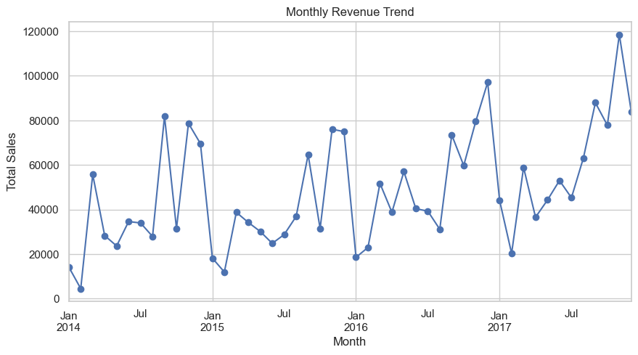
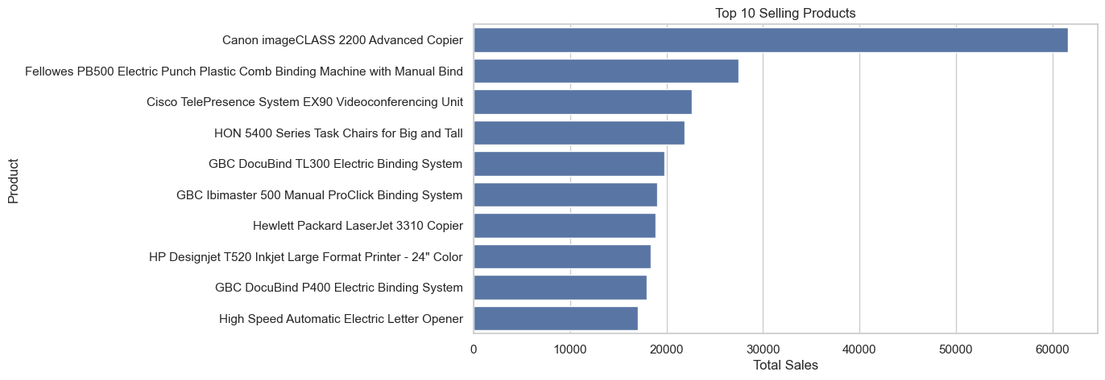
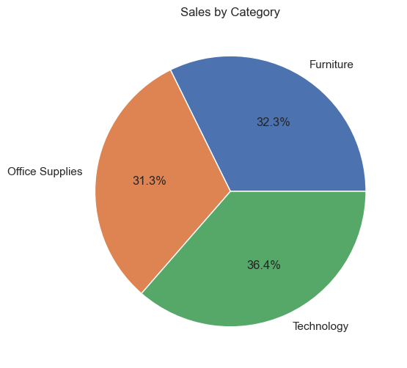
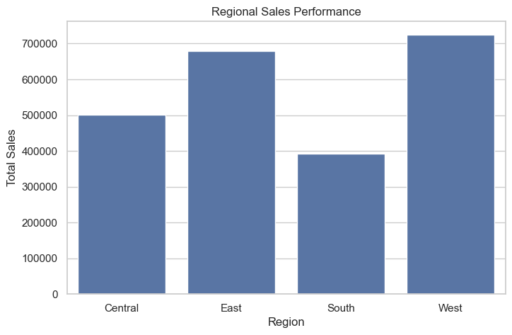
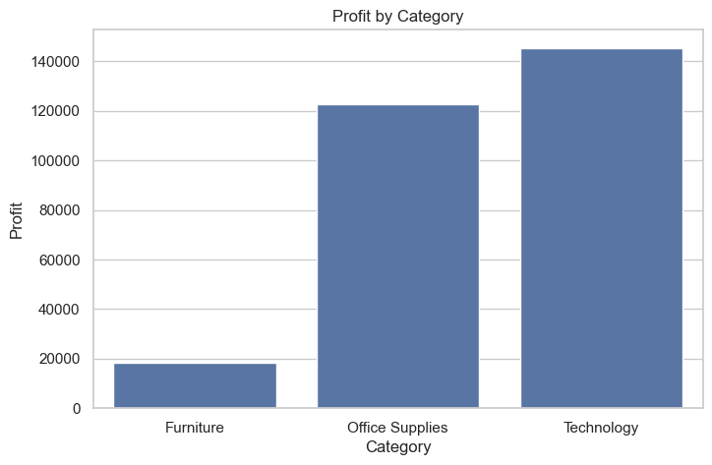

Total Sales: 2297200.8603
Total Profit: 286397.0217
Total Orders: 5009

